**Prueba.**

Las segunda y tercera sentencia se ejecutan correctamente.

Practica 1(dispositiva 30)

SELECT *

FROM employees;

SELECT department_name

FROM departments;

**Actividades.**

**Ej1.**

verdadero

**Ej2.**

Falso (no existe tabla job_grades)

**Ej3.**

SELECT employee_id, last_name, salary * 12 AS “ANNUAL SALARY”

FROM employees;

**Ej4.**

DESCRIBE departments;

SELECT *

FROM departments;

**Ej5.**

DESCRIBE employees;

SELECT employee_id, last_name, hire_date as “STARTDATE”, job_id

FROM employees;

**Ej6.**

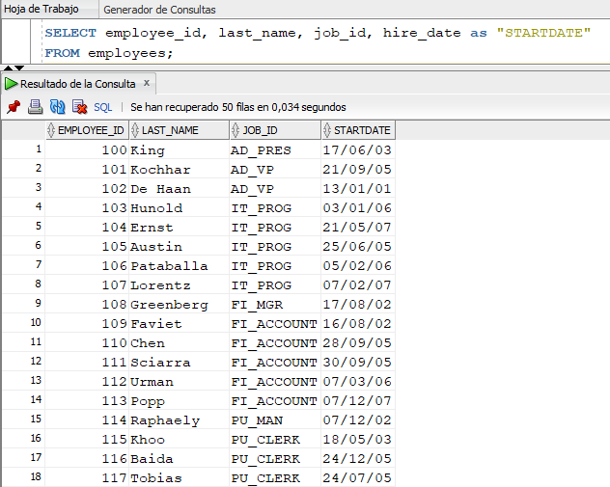

**Ej7.**

SELECT DISTINCT job_id

FROM employees;

**Ej8.**

SELECT employee_id AS “EMP #”, last_name AS “Employee”, job_id AS “Job”, hire_date as “Hire Date”

FROM employees;

**Ej9.**

SELECT first_name || ',' || job_id AS "Employee and Title"

FROM employees;

**Ej10.**

SELECT employee_id || ',' || first_name || ',' ||

last_name || ',' || email || ',' ||

phone_number || ',' || hire_date || ',' ||

job_id || ',' || salary || ',' ||

commission_pct || ',' || manager_id

|| ',' || department_id AS "THE_OUTPUT"

FROM employees;